Stefan Cline

Math 636 – Mathematical Modeling

Homework #3

12 September 2021

Exercises

37: 2, 3, 5

38: 3

39: 1, 4

**Problem 37.2**

Water Bug growth model.

Here we’re given

$$\frac{1}{N}⋅\frac{dN}{dt}=α(f_{a}-f_{c})$$

Where $f_{a}$ is the available food and $f_{c}$ is the food consumption. We also are given:

$$f_{c}=βN+γ⋅\frac{dN}{dt}$$

Now, we’ll plug $f_{c}$ into the equation above:

$$\frac{1}{N}⋅\frac{dN}{dt}=α\left(f_{a}-\left(βN+γ⋅\frac{dN}{dt}\right)\right)$$

$$\frac{dN}{dt}=αNf_{a}-αN\left(βN+γ⋅\frac{dN}{dt}\right)$$

$$\frac{1}{N}⋅\frac{dN}{dt}=αNf_{a}-αβN^{2}-αγN⋅\frac{dN}{dt}$$

$$\frac{dN}{dt}+αγN⋅\frac{dN}{dt}=αNf_{a}-αβN^{2}$$

$$\frac{dN}{dt}\left(1+αγN\right)=αN\left(f_{a}-βN\right)$$

$$\frac{dN}{dt}=\frac{αN\left(f_{a}-βN\right)}{\left(1+αγN\right)}$$

Hence, the above differential equation describes this model.

In order to find the equilibrium populations, we’ll want to set our above differential equation to $0$, i.e. the value at which we see no change in our population.

$$\frac{dN}{dt}=\frac{αN\left(f_{a}-βN\right)}{\left(1+αγN\right)}=0$$

$$αN\left(f_{a}-βN\right)=0$$

Here we clearly have the trivial case of $N=0$, i.e. no population means no growth, so $N_{e_{1}}=0$. But also:

$$f_{a}-βN=0$$

$$βN=f_{a}$$

$$N=\frac{f_{a}}{β}$$

So we have that $N_{e_{2}}=\frac{f_{a}}{β}$.

As a side note, we can assume alpha is positive because a negative alpha would make the model function such that we have population growth when more food is being consumed than is available, which doesn’t make sense. We’re given that $γ$ is positive. Obviously $β$ must be positive, otherwise the food consumption variable would comprise of a negative population at time $t$, which of course makes no realistic sense. And lastly we know $f_{c}$ must be positive otherwise that would imply the bugs are somehow planting crops or adding food to their own ecosystem, which would be remarkably impressive, but likely impossible.

**Problem 37.3**

Consider the following models of population growth. Assume $a>0, b>0$. For each case, describe possible birth and death mechanisms.

(a) $\frac{dN}{dt}=-aN+bN^{2}$

Here, we see that if $N$ is proportionally below some critical threshold, the population will die out, hence, small initial $N$ values can lead to extinction whereas larger initial $N$ values can lead to exponential growth. An example of this could be something like say a pack of wildebeest. If there are only a handful of them, they may be easily picked off and not have enough time to reproduce. If there are however substantial numbers of them, those that die will quickly be replaced by the mass of the herd producing new offspring.

(b) $\frac{dN}{dt}=-aN-bN^{2}$

Here we assume that $N$ cannot be less than zero as it’s a population. Therefore, this model is predicting catastrophic death of a species (no growth mechanism), where the higher the number of existing members, the faster they die out. This could be possibly modeled by something like an extremely deadly disease spreading through a population living in a contained area. The more they interact with one another (via higher populations implying more rapid spreading), the faster they transmit and contract the disease and therefore die off.

(c) $\frac{dN}{dt}=aN+bN^{2}$

Here we have unchecked growth. In this model small populations grow slower, but exponentially grow nonetheless. Also, large populations grow much faster. There is no death mechanism. An example of this could be a new species is introduced to an area with no natural predators. They therefore have nothing to hinder their growth and initially grow without bound.

(d) $\frac{dN}{dt}=aN-bN^{2}$

For this situation let’s solve it using MAPLE. (Replacing $N→y$, and $t→x$)

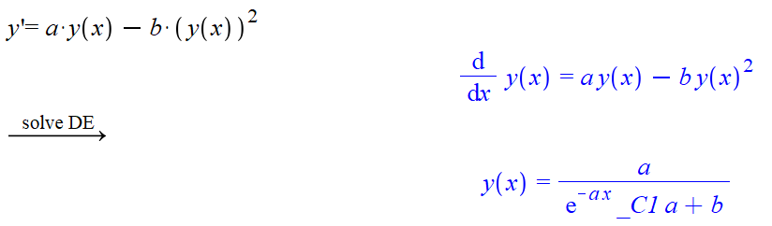

Here we have a much more complicated model. As $x$ (or $t$) approaches infinity, we see that our population will stabilize at $\frac{a}{b}$. But, we’re dealing with populations. For simplicity’s sake, assume that we’re measuring individuals (i.e. a number for $N$ must practically be an integer), then we must have that $a>b$ for the population to survive. Therefore, these coefficients are critical to determining the growth or death of the population – effectively their measured values are the death/growth mechanisms of the system. This model might be better viewed logistically as: $N^{'}=N(a-bN)$. This helps to really show that the $a$ value must be able to “overcome” the $b$ value in order for the population to stabilize at some equilibrium. We can also note that if $N$ is being measured in say the tens of thousands, then $a$ can be less than $b$, but it will imply a lower overall long term population.

**Problem 37.5**

Logistic Equation model.

We’re informed that the population’s instantaneous growth rate is 27% per year when not effected by crowding, so we have that $a=0.27$. We also get that $\frac{12}{1000}$ decrease in the birth rate and $\frac{50}{1000}$ increase in the death rate. Therefore, we know:

$$\frac{1}{N}⋅\frac{dN}{dt}=R\left(N\right)=0.27-0.012-0.05=0.208$$

Now, we’ll set this equal to our expanded equation for the rate with $N=1000$:

$$a-bN=0.208$$

$$0.27-b(1000)=0.208$$

$$-b(1000)=-0.062$$

$$b=\frac{0.062}{1000}=0.000062$$

Plugging this all back in we arrive at:

$$\frac{dN}{dt}=N\left(0.27-0.000062N\right)$$

Now, we wish to find the equilibrium points:

$$N\left(0.27-0.000062N\right)=0$$

$$0.27-0.000062N=0$$

$$N=\frac{0.27}{0.000062}≈4,354.84$$

Therefore we expect an equilibrium at roughly $N=4354.84$.

**Problem 38.3**

Consider Smith’s model of population growth (see exercise 37.2)

$$\frac{dN}{dt}=\frac{αN(f_{a}-βN)}{1+αγN}$$

From 37.2 we know that $N_{e_{1}}=0,$ and $N_{e_{2}}=\frac{f_{a}}{β}$. We’ll first examine $N_{e_{1}}=0+ϵ$ where $ϵ≪1$. (We note that we won’t test $N-ϵ$ because that would correspond to negative populations which don’t exist in our model).

$$\frac{dN}{dt}=\frac{α\left(0+ϵ \right)(f_{a}-β\left(0+ϵ \right))}{1+αγ\left(0+ϵ \right)}$$

$$=\frac{αϵ(f_{a}-βϵ)}{1+αγϵ}$$

Here we know all of our values, $f_{a},β,γ$ and $α$ are positive and $ϵ$ is very small. Hence:

$$≈\frac{αϵ\left(f_{a}\right)}{1}>0$$

Hence, we see that our derivative at that point is positive and therefore we can conclude that the population is trending away from zero. Hence zero is an unstable equilibrium.

Now we test $N_{e_{2}}±ϵ=\frac{f_{a}}{β}±ϵ$. First plus $ϵ$:

$$\frac{dN}{dt}=\frac{αN(f_{a}-βN)}{1+αγN}$$

$$=\frac{α\left(\frac{f_{a}}{β}+ϵ\right)\left(f_{a}-β\left(\frac{f_{a}}{β}+ϵ\right)\right)}{1+αγ\left(\frac{f_{a}}{β}+ϵ\right)}$$

$$=\frac{\left(\left(\frac{αf_{a}}{β}+αϵ\right)\left(f_{a}-f_{a}-βϵ\right)\right)}{1+αγ\left(\frac{f_{a}}{β}+ϵ\right)}$$

$$=\frac{\left(\left(\frac{αf_{a}}{β}+αϵ\right)\left(-βϵ\right)\right)}{1+αγ\left(\frac{f_{a}}{β}+ϵ\right)}$$

From here, though our expression looks complicated, we’re finished! The negative term, $-βϵ$, will make the overall value of $\frac{dN}{dt}$ evaluated with a small positive perturbation be negative. Hence populations greater than $N_{e_{2}}$ will be drawn back to it.

Now for negative perturbations from $N_{e_{2}}$:

$$\frac{dN}{dt}=\frac{αN(f_{a}-βN)}{1+αγN}$$

$$=\frac{α\left(\frac{f_{a}}{β}-ϵ\right)\left(f_{a}-β\left(\frac{f_{a}}{β}-ϵ\right)\right)}{1+αγ\left(\frac{f_{a}}{β}-ϵ\right)}$$

$$=\frac{\left(\left(\frac{αf_{a}}{β}-αϵ\right)\left(f_{a}-f_{a}+βϵ\right)\right)}{1+αγ\left(\frac{f_{a}}{β}-ϵ\right)}$$

$$=\frac{\left(\left(\frac{αf_{a}}{β}-αϵ\right)\left(βϵ\right)\right)}{1+αγ\frac{f_{a}}{β}-aγϵ}$$

From here we see that whatever $αf_{a}/β$ is, it will be larger than $αϵ$. Hence our numerator is positive. Also, we similarly see that our denominator is larger positive terms minus a smaller $αγϵ$ term. Hence, we expect the denominator to also be positive. Therefore, overall, with a small negative perturbation, $\frac{dN}{dt}>0$.

With both the right and the left drawing points back to $N_{e_{2}}$ we see that $N_{e_{2}}$ is stable.

Altogether: $N_{e_{1}}=0:Unstable, N_{e_{2}}=\frac{f_{a}}{β}:Stable.$

**Problem 39.1**

Consider $\frac{dN}{dt}=αN^{2}-βN$ (with $α>0$, $β>0$).

(a) How does the growth rate depend on the population?

Here, for simplicity if we assume that $α=β$, then we see that a smaller population, $N<1$, will result in a decrease in the overall population meaning we’ll have a declining growth rate. If we have a larger population, $N>1$, then we see the population will increase, meaning our growth rate will increase. Now, if we have that $α≠β$ we can see

$$0=αN^{2}-βN$$

$$0=αN-β$$

$$N=\frac{β}{α}$$

So, if we have that $N=\frac{β}{α}$ we have no growth or decrease. If we have any value larger than that, we see an increase in the growth rate, anything less we see a decrease in the population rate.

(b) Sketch the solution in the phase plane.

We can see that this equilibrium point is unstable. So, we have:

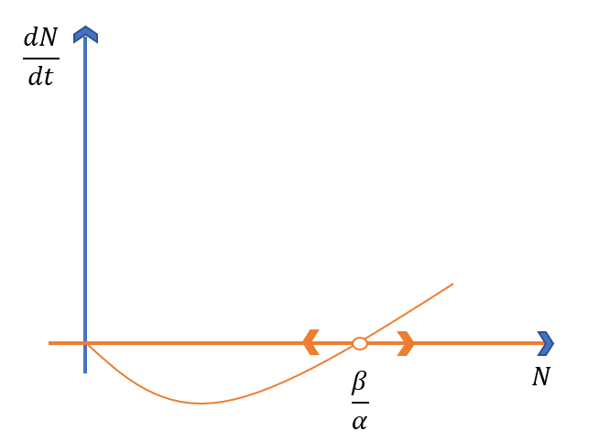

(c) Obtain the exact solution.

$$\frac{dN}{dt}=αN^{2}-βN$$

$$dN⋅\frac{1}{αN^{2}-βN}=dt$$

$$\int{\frac{1}{αN^{2}-βN}dN}=\int{dt}$$

$$\int{\frac{1}{\left(α-\frac{β}{N}\right)N^{2}}dN}=t+C_{1}$$

Now, let $u=a-\frac{β}{N},$ so $\frac{du}{dN}=\frac{β}{N^{2}}$, $dN=\frac{N^{2}}{β}du$. Plugging this in and substituting:

$$\int{\frac{1}{\left(u\right)N^{2}}\frac{N^{2}}{β}du}=t+C_{1}$$

$$=\frac{1}{β}\int{\frac{1}{u}du}=t+C_{1}$$

$$\frac{1}{β}\ln\left(u\right)+C_{2}=t+C_{1}$$

$$\frac{1}{β}\ln\left(α-\frac{β}{N}\right)=t+C$$

$$\ln\left(α-\frac{β}{N}\right)=tβ+C$$

$$α-\frac{β}{N}=Ce^{tβ}$$

$$\frac{β}{N}=-Ce^{tβ}+α$$

$$N(t)=\frac{β}{-Ce^{tβ}+α}$$

(d) Show how both parts, (b) and (c) illustrate the following behavior:

(i) If $N_{0}>\frac{β}{α}$, then $N→∞$. At what time does $N→∞$?

From part (b) we see that any input value of $N>\frac{β}{α}$ starts the trend of $N$ tending towards infinity on the graph. Analytically from part (c) we see that it will tend towards infinity as the denominator approaches positive 0.

$$-Ce^{tβ}+α=0$$

$$Ce^{tβ}=α$$

$$e^{tβ}=\frac{α}{C}$$

$$tβ=\ln\left(\frac{α}{C}\right)$$

$$t=\frac{1}{β}⋅\ln\left(\frac{α}{C}\right)$$

This is the point at which for $t$ that $N$ approaches infinity (with the implied step that $α>Ce^{tβ}$).

(ii) If $N_{0}<\frac{β}{α}$, then $N→0$.

From our image in part (b) again we see that any value less than $\frac{β}{α}$ will tend towards zero, so if our growth rate is negative, we can expect our population to approach zero. Analytically, assuming $t_{0}=0$ for our $N_{0}$:

$$N_{0}=N(t_{0})=\frac{β}{-Ce^{(0)β}+α}$$

$$N_{0}=\frac{β}{-C+α}$$

Then, we see that for any value where $C<0$, we’ll have $N_{0}<\frac{β}{α}$. This makes sense, as we observe a positive term becoming exponentially large, i.e. $\lim_{t→∞}{\frac{β}{-Ce^{tβ}+α}},$ if $C<0$ (making $N_{0}<\frac{β}{α}$) then we have

$$\lim_{t→∞}{\frac{β}{-Ce^{tβ}+α}}=0$$

(iii) What happens if $N_{0}=\frac{β}{α}$?

From our image in (b) we see we’re at an unstable equilibrium. Analytically we have:

$$N(t)=\frac{β}{-Ce^{tβ}+α}$$

$$N_{0}=N\left(0\right)=\frac{β}{α}=\frac{β}{-Ce^{(0)β}+α}$$

$$\frac{β}{α}=\frac{β}{-C+α}$$

This then implies that $C=0$ as it’s the only way to make the expressions equal. This means that:

$$N\left(t\right)=\frac{β}{-Ce^{tβ}+α}=\frac{β}{α}$$

Effectively, for any time $t$, $N=\frac{β}{α}$.

**Problem 39.4**

Consider the following growth model:

$\frac{dN}{dt}=aN+bN^{2}$ with $a>0$, $b>0$.

(a) How does growth rate depend on $N$.

Here, the growth rate will simply get larger faster depending on whatever value for $N$ is selected – larger values for $N$ will make growth quicker whereas smaller ones will make it grow less quickly, but regardless the growth rate will continue to increase. As both terms are positive, even extremely small values for $N$ lead to extremely rapid growth.

(b) What would you expect happens to the population?

It will increase without bound. This model doesn’t seem particularly accurate for long time scales because it predicts boundless growth.

(c) By using the phase plane, show that the population tends towards infinity.

Here we’ll try to find our equilibria, i.e., when our growth rate is zero:

$$\frac{dN}{dt}=aN+bN^{2}=0$$

$$N(a+bN)=0$$

$$N=-\frac{a}{b}, N=0$$

We see that $N=0$ is an equilibrium, and that $-a/b$ is also one. But $a$ and $b$ are both positive, and therefore would imply that another equilibria is at a negative population value which is nonsensical for our model. Hence, $N=0$ is the only sensible equilibrium point. This gives the following phase portrait:

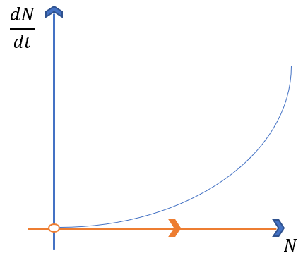

(d) By considering the exact solution, show that the population reaches infinity in *finite* time; what might be called a population explosion.

$$\frac{dN}{dt}=aN+bN^{2}$$

$$\frac{1}{aN+bN^{2}}dN=dt$$

$$\int{\frac{1}{aN+bN^{2}}dN}=\int{dt}$$

$$\int{\frac{1}{\left(\frac{a}{N}+b\right)N^{2}}dN}=t+C_{1}$$

Let $u=\frac{a}{N}+b$, $\frac{du}{dN}=-\frac{a}{N^{2}}$, $dN=\frac{du}{-a}N^{2}$, then:

$$\int{\frac{1}{\left(u\right)N^{2}}\left(\frac{du}{-a}N^{2}\right)}=t+C_{1}$$

$$-\frac{1}{a}\int{\frac{1}{\left(u\right)}\left(du\right)}=t+C_{1}$$

$$-\frac{1}{a}\ln\left(u\right)+C_{2}=t+C_{1}$$

$$-\frac{1}{a}\ln\left(\frac{a}{N}+b\right)=t+C$$

$$-\ln\left(\frac{a}{N}+b\right)=at+aC$$

$$\ln\left(\frac{a}{N}+b\right)=-at-aC$$

$$\frac{a}{N}+b=e^{-at-aC}$$

$$\frac{a}{N}=e^{-at-aC}-b$$

$$N(t)=\frac{a}{e^{-at-aC}-b}$$

We’ll solve for $C$ in terms of $N_{0}$ to give the input of an initial population. This will also help make sure our parameter inputs make sense.

$$N\left(0\right)=N_{0}=\frac{a}{e^{-aC}-b}$$

$$e^{-aC}-b=\frac{a}{N_{0}}$$

$$e^{-aC}=\frac{a}{N_{0}}+b$$

$$-aC=\ln\left(\frac{a}{N_{0}}+b\right)$$

$$C=-\frac{1}{a}\ln\left(\frac{a}{N_{0}}+b\right)$$

Now, to see where this population explodes towards infinity, we see where:

$$\exp\left(-at-a\left(-\frac{1}{a}\ln\left(\frac{a}{N_{0}}+b\right)\right)\right)-b=0$$

$$\exp\left(-at-a\left(-\frac{1}{a}\ln\left(\frac{a}{N_{0}}+b\right)\right)\right)=b$$

$$-at+a\left(\frac{1}{a}\ln\left(\frac{a}{N_{0}}+b\right)\right)=\ln\left(b\right)$$

$$-at=\ln\left(b\right)-a\left(\frac{1}{a}\ln\left(\frac{a}{N_{0}}+b\right)\right)$$

$$t=\frac{1}{a}\ln\left(\frac{a}{N_{0}}+b\right)-\frac{1}{a}\ln\left(b\right)$$

$$t=\frac{1}{a}\left(\ln\left(\frac{a}{N_{0}}+b\right)-\ln\left(b\right)\right)$$

$$t=\frac{1}{a}\left(\ln\left(\frac{\frac{a}{N_{0}}+b}{b}\right)\right)$$

$$t=\frac{1}{a}\ln\left(\frac{a}{N_{0}b}+1\right)$$

Here we see an asymptotic explosion point. As $t$ approaches this value from the left, the value for $N(t)$ will rapidly approach infinity.